Watermelon Bowl
By Helen Castaneda
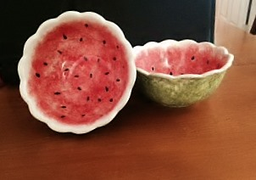
Project Piece: Miscellaneous
Duncan Scalloped Bowl Palette knife Foil, Glazed Tile, or Palette Paper
Brushes Sea wool sponge or silk sponge
#6 Fan Glaze Water Bowl
#1 Liner Fan
#4 Round
Glaze
Pure Brilliance
Concept
CN182 Light Kiwi CN372 Bright Honeysuckle
CN182 Bright Kiwi CN384 Fruit Punch
CN183 Dark Kiwi CN074 Really Red
CN253 Black

PREPARING THE PIECE:
- With damp sponge, wipe bowl to remove dust and prepare for painting making sure the front and back of the bowl is clean of dust.
- Sponge on a one coat of CN182 Light Kiwi to the bottom and outside of the bowl
- Sponge on a one coat of CN183 over Light Kiwi to the bottom and outside of bowl
- Sponge on a one coat of CN184 Dark Kiwi over the Bright Kiwi to the bottom and outside of bowl
- Leave about ¾ “ to top of inside of bowl without any sponging (it will be the rind of the watermelon)
- Sponge on one coat to the inside and the bowl with CN372 Bright Honeysuckle.
- Sponge on one coat over the CN372 to the inside of bowl with CN384 Fruit Punch
- Sponge on one coat to the inside of bowl over the other CN’s with CN074Really Red

- With a CN253 Black #4 Round apply the watermelon seeds to the red top anywhere you would like

- Don’t forget to sign your piece with a #1 Liner.
- When Dry Glaze to the inside of bowl with glaze brush or sponge the outside. Let completely dry.
- Stilt and fire to shelf cone 06.
- Remember to remove stilt marks.

