FLOWER TEA TIME MUG
By Helen Castaneda

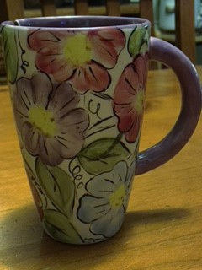Project Piece: Miscellaneous
33427 Tea Bag Mug Palette knife
Foil, Glazed Tile, or
Brushes Palette Paper
#1 Liner Silk Sponge
#2, #4, #6 Round Fan
#6 Fan Glaze Water Bowl
Blue painters tape
EZ Stroke small plastic cup
EZ012 Black Red pencil or pencil
Dotter
Glaze Old stiff brush
Pure Brilliance

Concept
CN011 Light Straw CN182 Bright Kiwi
CN074 Really Red CN183 Dark Kiwi
CN081 Light Wine CN232 Bright Briarwood
CN111Light Delft CN244 Really White
CN131 Light Tidepool CN292 Bright Purple CN181 Light Kiwi
PREPARING THE PIECE
With damp sponge, wipe your piece to remove dust and prepare for painting making sure the inside bottom of the mug is clean of dust.

Put tape over the tea bag slit at top of mug. Thin CN292 Bright Purple to a milk consistence and roll or brush the inside of the mug making sure that the concept does not seep over to the front of mug remove tape when almost dry.
Draw flowers and leaves by penciling in on mug.
Using #4 or #6 Round brush apply CN292 Bright Purple on to the handle of the mug with 3 coats.
Using #4 or #6 Round brush load in CN244 Really White, side load in CN074 Really Red then apply onto any flowers. then repeat process by choosing another flower and color by loading CN111 Light Delft, side load into CN131 Light Tidepool Repeating process loading with CN244 Really White, side load in CN292 Bright Purple on a new flower, loading CN244 Really White, side load CN081 Light Wine and side load CN074 and continue until you fill all the flowers.
Apply the CN181Light Kiwi and side load CN182 Bright Kiwi and CN 183 Dark Kiwi to make the leaves with a#1 Round brush.
Using CN011 Light Straw, pounce with # old brush into center of flowers using CN323 Bright Briarwood to putting dots on to lower half of flowers.
Outline Flowers and leaves using #1 liner and EZ012 Black (thin with a little water making it ink like) also add flower tentacles
When completely dry using Fan Brush Glaze roll or brush inside and outside of mug with Pure Brilliance.
Let completely dry then stilt and fire to shelf cone 06 and remember to remove stilt marks after firing.

